IDO-SOM2D01 DATASHEET

IDO-SOM2D01 Module Datasheet 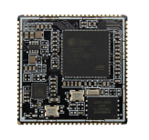

**1． Module Overview**

IDO-SOM2D01 is an ultra-small SOM (System On Module) module based on SigmaStar SSD201 SoC (ARM Cortex A7 Core). The module integrates WiFi, NAND and power management circuits on a 2.95cm x 2.95cm PCB. It can be applied to smart display, buildingintercom indoor unit, medical electronics, voice recognition home appliance and IoT smart gateway, etc. It has carried out strict power integrity and signal integrity simulation design, and has passed various electromagnetic compatibility, temperature shock, high temperatureand high humidity aging, long-term storage pressure and other tests. It is stable and reliable, and can be supplied in batches.

**Key Features:**

◆ Default configuration 64MB DDR2，128MB Nand Flash（up to 2GB）◆ Ultra small size（29.5mm*29.5mm）. Single-sided layout, fully shielded on the back, optional shielding cover on the front

◆ The back of the PCB is completely flat and has no traces, and the board can be routed at will without interference

◆ Supports Linux system, super fast boot within 1s

◆ Integrates 1 way 10/100M PHY

◆ Strict signal integrity and power integrity design and test

◆ 96Pin with 1.1mm pitch，extends all pin resources of SSD201 The internal functional block diagram of SigmaStar is as folloIws:

Wireless-Tag Technology Co., Limited http://www.wireless-tag.comShenzhen Tactile Intelligent Technology Co., Ltd. http://www.industio.com

IDO-SOM2D01 DATASHEET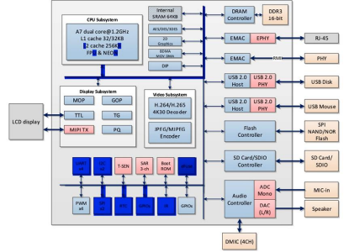

The detailed specifications of the module are as follows:

| **Items** | **Specifications** |
| --- | --- |
| CPU | SigmaStar SSD201  ARM® Cortex-A7 dual-core processor, up to 1.2GHz |
| Video | processor Supports max. resolution FHD (1920x1080)/60fps decoding, H.265/HEVCDecoder, I/P/B slices ， all intra-prediction modes, all inter-predictionmodes, supports max. resolution HD (1920x1080)/60 fps decoding |
| Power supply | Input voltage 3.3V |
| RAM | Embedded DDR2/DDR3 memory, supports auto-refresh and  mode， 64MB |
| Storage | Supports 1/2/4-bit SPI-NOR/SPI-NAND Flash，default 128MB（Upto2GB） |
| System | Linux |
| Ethernet | Supports two Ethernet ports，supports 10/100Mbps half/full duplex，onebuilt-in 10/100M Ethernet PHY, supports one RMII to connect externalPHY |

self-refresh

Wireless-Tag Technology Co., Limited http://www.wireless-tag.comShenzhen Tactile Intelligent Technology Co., Ltd. http://www.industio.com

IDO-SOM2D01 DATASHEET

| WIFI/BT | Equipped with Singmaster wifi chip（SSW101B），with high performance, and 500 meters transmission distance in open space |
| --- | --- |
| Display | Supports mipi/RGB interface：  MIPI TX DSI 4-lan with max，1.5Gbps and output up to FHDSupports FHD graphic layer with4/8,ARGB1555/ARGB4444/ARGB8888,RGB565,and YUV422 format. |
| Audio | 1 x Mono AMIC  1 x Dual channel DMIC  1 x LINEOUTR/L，supports 8K/16K/32K/48KHz Sampling Rate； |
| USB | 1 x USB 2.0 HOST |
| Infrared | 1 x Infrared receiving interface（PM_IRIN） |
| Peripherals | 4 x UART（PM_UART is used as Debug Serial by default）  1 x SDIO2.0 （Data bus 1/4 bit mode, compatible with SD2.0）  2 x I2C、1 x I2S、1 x SPI、4 x PWM、several GPIOs |
| Dimensions | 29.5mm x 29.5mm |
| Interface | Type Stamp hole（96 PIN， 1.1mm pin pitch） |
| PCB | 1.2mm thickness, 4-layer board, high Tg material, immersion  process |
| Weight | 8g |

Shenzhen Tactile Intelligent Technology Co., Ltd. http://www.industio.com

60fps；

Index

Specification

gold

**2． IDO-SOM2D01 Module Block Diagram 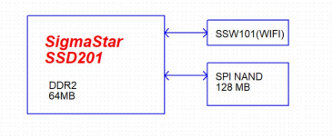**Figure 2. IDO-SOM2D01 Module Block Diagram

**3． IDO-SOM2D01 Pin Definition**

Wireless-Tag Technology Co., Limited http://www.wireless-tag.com

IDO-SOM2D01 DATASHEET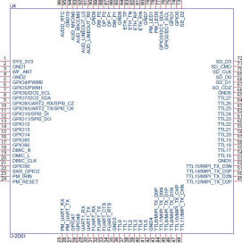

Figure 3. IDO-SOM2D01 module pin definition

Note: For detailed pin definitions and function multiplexing, please refer to the document "IDO-SOM2D01 Pinout.pdf".

**4． Module Dimensions**

Unit: mm

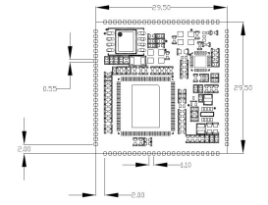

Figure 4. IDO-SOM2D01 dimensions

Wireless-Tag Technology Co., Limited http://www.wireless-tag.comShenzhen Tactile Intelligent Technology Co., Ltd. http://www.industio.com

IDO-SOM2D01 DATASHEET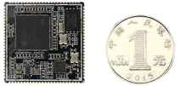

Figure 5. Comparison between IDO-SOM2D01 module and one yuan coin 5． **Module electrical parameters**

| **Power** | **pin** | **Min** | **Max Current** | **Power supply ripple requirements** |
| --- | --- | --- | --- | --- |
| SYS_3V3 |  | 3.2V | 3.4V | <30mVrms |

**6． Product ordering**

| **Order Part Number** | **DDR3L** | **ROM** | **Main frequency** | **Temperature** |
| --- | --- | --- | --- | --- |
|  |  |  |  |  |
|  |  |  |  |  |
|  |  |  |  |  |
|  |  |  |  |  |

Wireless-Tag Technology Co., Limited http://www.wireless-tag.comShenzhen Tactile Intelligent Technology Co., Ltd. http://www.industio.com